# Assignment 2

## 1. What's Riccardo's estimated knowledge of CogSci? What is the probability he knows more than chance (0.5)

Using grid approximation, the sum of the posteriors for parameter values > 0,5 (chance) is 0.5 meaning that there is 50% chance that Riccardo knows more than chance with 3 correct answers out of 6 possible.

A quadratic approximation yields the answer of mean = 0.5 and SD = 0.2,

## 2. Estimate all the teachers' knowledge of CogSci. Who's best? Use grid approximation. Comment on the posteriors of Riccardo and Mikkel.

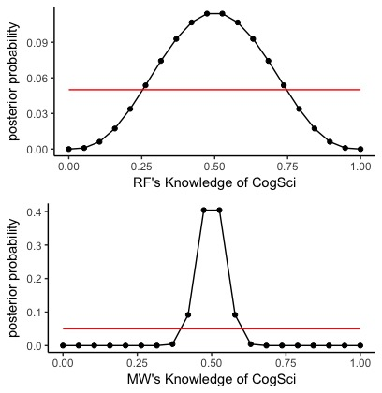

Plot 1 Top: Posterior distribution of Riccardo's knowledge of Cog Sci, Bottom: The posterior distribution of Mikkel's knowledge of Cog Sci

Both plots are centred around 0.5 (chance) however Riccardo’s is wider. This is because he has less observations so the posterior is less ‘sure’

## 2a. Produce plots of the prior, and posterior for each teacher.

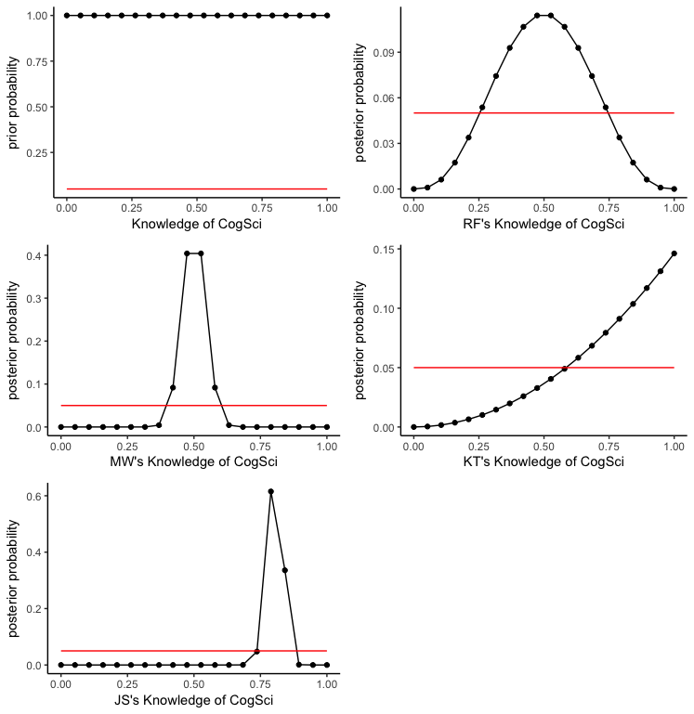

# 3. Change the prior. The prior is now a normal distribution with a mean of 0.8 and a standard deviation of 0.2. Do the results change (and if so how)?

3a. Produce plots of the prior and posterior for each teacher.